

DC 101 Project: CSS Student Information System

Documentation  
Project report

Prepared by Zeus Sevilla

KLL BSCS 2C

Final Project for DC 101

January 4, 2026



introduction

The **CCS Student Information System (SIS)** is a web-based application designed to manage and organize student records for the College of Computer Studies (CCS). The system aims to provide an efficient way to store, retrieve, update, and manage student-related data such as personal information, department, year and section, and enrolled courses.

The primary purpose of the system is to replace manual or spreadsheet-based record keeping with a centralized digital platform. This improves data accuracy, accessibility, and consistency while reducing redundancy and human error. The system also allows administrators to manage departments, sections, and course subjects in an organized manner.

# Web Interface: Key Pages and Functionalities

# 1. Student Management Page

**Features:**

* Displays a table of all students
* Add, edit, and delete student records
* Search students by name or student ID
* Sort student data in ascending or descending order
* Dropdown selections for Department (ACT / BSCS) and Year & Section

# 2. Department Management Page

**Features:**

* Displays CCS departments (ACT and BSCS)
* Filters students based on department
* Manages Year & Section entries
* Add and delete sections dynamically
* Organized viewing of students per department

# 3. Course Management Page

**Features:**

* Displays list of courses in a table format
* Add, edit, and delete course records
* Stores course ID, name, description, and credit units
* Provides a structured way to manage academic subjects

# 3. Setting Management Page

**Features:**

* Controls Dark/Light Theme
* Manage Acounts and Password
* Logout and Clear LocalData

# 3. Login and Home Page

**Features:**

* Displays Login ID and Password
* Displays Main Page for Student, Department, Course and Setting Redirectories

**Database Design: ER Diagram, Table Description, and Relationships**

**ER Diagram**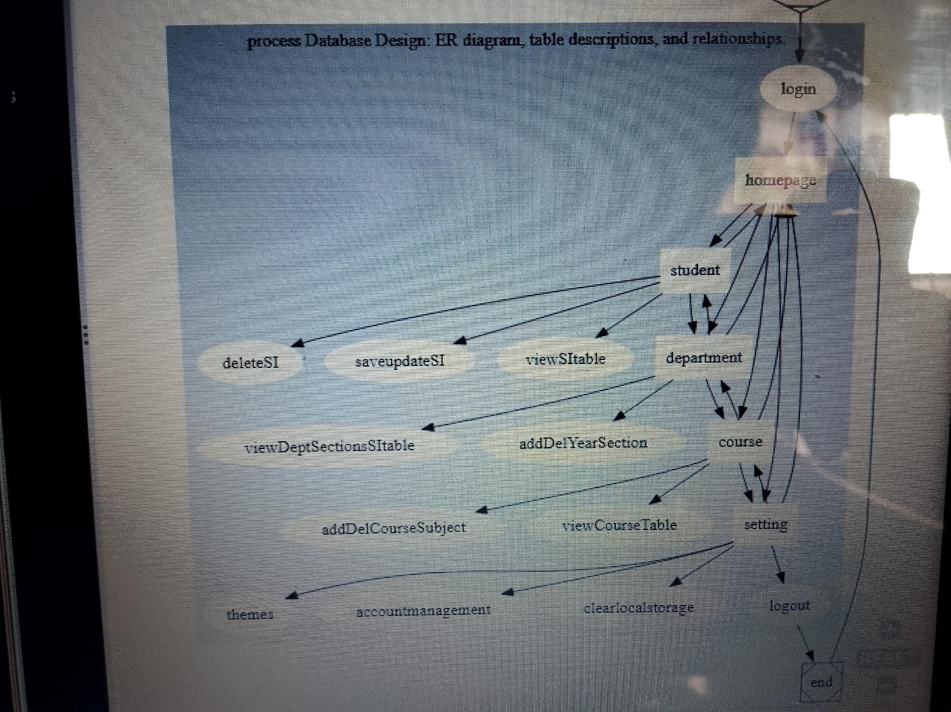

**Table Descriptions**

1. **Student Management Page**

|  |  |  |
| --- | --- | --- |
| **Field Name** | **Data Type** | **Description** |
| **student_id** | **VARCHAR** | **Unique Student Identifier** |
| **last_name** | **VARCHAR** | **Student lastname** |
| **first_name** | **VARCHAR** | **Student name** |
| **middle_initial** | **CHAR** | **Student middle initials** |
| **department** | **VARCHAR** | **BSCS or ACT** |
| **year_section** | **VARCHAR** | **Year and Section** |
| **gender** | **VARCHAR** | **Gender** |
| **birth_date** | **DATE** | **Date of Birth** |
| **age** | **INT** | **Student Age** |
| **email** | **VARCHAR** | **Email address** |
| **contact** | **VARCHAR** | **Contact number** |
| **address** | **TEXT** | **Home address** |

1. **Department Table**

|  |  |  |
| --- | --- | --- |
| **Field name** | **Data Type** | **Descriptions** |
| **department_id** | **VARCHAR** | **Department code (BSCS or ACT)** |
| **Department_name** | **VARCHAR** | **Department name** |

1. **Year and Section Table**

|  |  |  |
| --- | --- | --- |
| **Field Name** | **Data Type** | **Description** |
| **section_id** | **INT** | **Unique section id** |
| **Department_id** | **VARCHAR** | **Linked department** |
| **Year_section** | **VARCHAR** | **Ex: 1A, 2C, 3B** |

1. **Course Table**

|  |  |  |
| --- | --- | --- |
| **Field Name** | **Data Type** | **Description** |
| **course_id** | **VARCHAR** | **Course code** |
| **Course_name** | **VARCHAR** | **Course name** |
| **description** | **TEXT** | **Course Description** |
| **data_units** | **INT** | **Number of unit** |

**Relationships**

* **A Department can have many Students**
* **A Department can have many Year & Sections**
* **A Student belongs to one Department and one Year & Section**
* **A Course is independent and can be associated with departments if extended in the future**

# Challenges and Learning:

# 1. Challenges Encoutered

One of the main challenges encountered was managing data relationships between students, departments, and year sections while ensuring data consistency. Another challenge was implementing search and sorting functionality efficiently using JavaScript, compiling and sorting the students html information data in each department and year & section in department html and using SQL. Designing a clean and user-friendly interface while maintaining functionality also required careful planning.

# 2. Learned Outcomes

Through this project, significant learning was gained in:

* Designing relational databases and ER diagrams
* Implementing CRUD (Create, Read, Update, Delete) operations
* Using HTML, CSS, and JavaScript for dynamic web applications
* Managing data persistence using localStorage
* Improving UI/UX design principles
* Understanding how real-world information systems are structured

This project enhanced problem-solving skills and provided practical experience in developing a functional web-based information system.

.

# 3. Conclusion

The CCS Student Information System successfully demonstrates how a web-based application can efficiently manage academic records. It serves as a strong foundation for future improvements such as database integration, authentication, and role-based access control. The project highlights the importance of proper system design, data organization, and user-centered development.

